Faster sound waves

Sound waves can be made with a loudspeaker.
The loudspeaker makes a louder sound wave when it moves a bigger distance in and out.

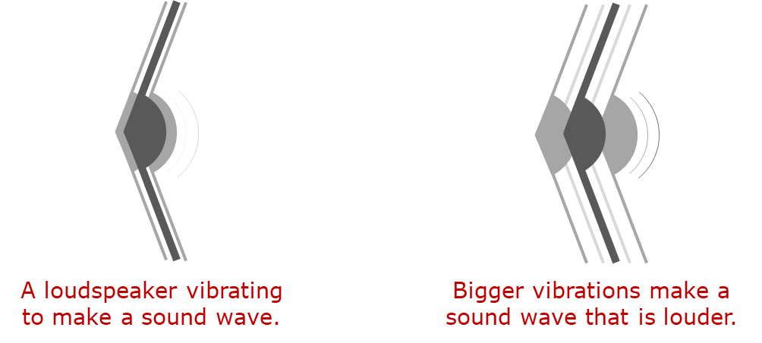
X
Y

1a. Which sound wave moves faster through the air?
Put a tick (✓) in the box next to the best answer.
A | Wave X moves faster.
B | Wave Y moves faster.
C | Both waves move at the same speed.

1b. What is the best reason for your last answer?
Put a tick (✓) in the box next to the best answer.
A | Both waves move through the same air.
B | It has more energy.
C | It has more force.
D | Fewer air particles need to move.

Sound waves can have different frequencies.
The loudspeaker has a higher frequency when it moves in and out more quickly.
A high frequency sound wave has a high note. It sounds squeaky.

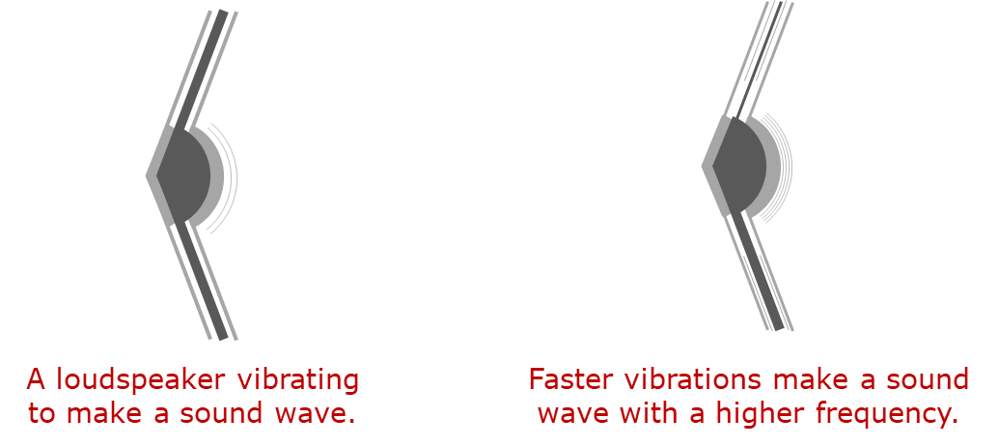
X
Y
2a. Which sound wave moves faster through the air?
Put a tick (✓) in the box next to the best answer.
A | Wave X moves faster.
B | Wave Y moves faster.
C | Both waves move at the same speed.

2b. What is the best reason for your last answer?
Put a tick (✓) in the box next to the best answer.
A | Both waves move through the same air.
B | It has more energy.
C | It has more force.
D | Fewer air particles need to move.

Physics > Big idea PSL: Sound, light and waves > Topic PSL4: Waves > Key concept PSL4.2: A wave model of sound
Diagnostic question
Faster waves

Overview
Learning focus: | As a sound wave (longitudinal wave) travels it transfers energy, as particles of the medium through which it travels are successively made to vibrate forwards and backwards along the direction in which the wave travels.
Observable learning outcome: | Compare the speed of sound waves that have a different frequency or loudness to each other and are moving through a common medium.
Question type: | Two-tier multiple choice
Key words: | Wave, longitudinal wave, amplitude, frequency

What does the research say?
The speed of a sound wave depends on the properties of the medium it is passing through. It is independent of the wave’s frequency or the size of disturbance (amplitude). In a study of 15- to 16-year-old science students (n=243), Caleon and Subramaniam (2010) found that a third of students thought sound waves travel faster when the sound is louder. A common reason given was that louder waves have more energy. Whilst louder waves do have more energy, amplitude does not affect the speed of a sound wave in normal conditions.
About a third of students the same study and nearly a third of university students enrolled onto a university physics course (n=92) believed higher pitched sounds travel faster (Caleon and Subramaniam, 2010; Tongchai et al., 2011). This is perhaps because of the experience that when cars approach at a higher speed the sound that the car makes has a higher pitch, due to the Doppler Effect. In this situation, the sound is not travelling through the air more quickly, instead it is the movement of the car that changes the frequency of sound – and it can only do this because the sound is travelling at a constant speed.
Ways to use this question
Students should complete the questions individually. This could be a pencil and paper exercise, or you could use an electronic ‘voting system’ or mini white boards and the PowerPoint presentation. The follow on question will give you insights into how they are thinking and highlight specific misconceptions that some may hold.
If there is a range of answers, you may choose to respond through structured class discussion. Ask one student to explain why they gave the answer they did; ask another student to explain why they agree with them; ask another to explain why they disagree, and so on. This sort of discussion gives students the opportunity to explore their thinking and for you to really understand their learning needs.

Differentiation
You may choose to read the questions to the class, so that everyone can focus on the science. In some situations it may be more appropriate for a teaching assistant to read for one or two students.
Expected answers
1a. C 1b. A
2a. C 2b. A
How to respond - what next?
The speed of a wave through a particular medium is constant. It does not change if the wave has either a higher frequency, or a bigger amplitude. Some students are likely to disagree with this.
Many students are likely to think that a wave with a bigger amplitude moves more quickly because it requires more force to set it going and a bigger force gives a bigger acceleration; or because it has more energy. A few students may think that the wave with a smaller amplitude moves more quickly because it creates less disturbance in the air, and it is easier to move a smaller quantity of something.
If students have misunderstandings about how the speed of sound waves with different amplitudes or frequencies to each other, and moving through a common medium, are all the same, it can help to demonstrate that this is so. This is easy to do by simply asking the students to listen to your voice, in order to decide whether words spoken more loudly or at a higher pitch ‘overtake’ other words, or whether all words arrive in the order they were spoken.
It is far more challenging to explain why sound waves all travel at the same speed through a particular medium. The full explanation goes beyond what students need to understand at this stage, but is included in the guidance notes for the BEST ‘Key concept’: A wave model of sound. This may be helpful to you for answering any challenging questions from students.
The speed of longitudinal waves of different loudness of frequency to each other can also be demonstrated on a slinky spring:-
Demonstrating longitudinal waves on a slinky spring.
A long ‘demonstration slinky spring’ is stretched out along a bench so that it is three or four metres long. The slinky is held by hand at each end and its length kept constant throughout the demonstration. A sharp forwards-and-backwards shake at one end should send a distinct wave pulse along the spring, and the pulse is reflected back from the other end.
Sending two pulses along the slinky, one immediately after the other, allows the speed of different types of pulse to be directly compared. If the second pulse follows at the same speed it will neither catch up nor fall further behind the first. Wave pulses of different amplitudes or different frequencies can be directly compared in this way.
Changing the length of the slinky will affect its tension. The tighter the spring is, the faster the waves will travel along it.
The following BEST ‘response activity’ could be used in follow-up to this diagnostic question:
- Response activity: School band

Acknowledgments
Developed by Peter Fairhurst (UYSEG).
Images: Peter Fairhurst (UYSEG).
References
Caleon, I. and Subramaniam, R. (2010). Development and Application of a Three-Tier Diagnostic Test to Assess Secondary Students' Understanding of Waves. International Journal of Science Education, 32:7, 939-961.
Tongchai, A., et al. (2011). Consistency of students' conceptions of wave propogation: Findings from a conceptual survey in mechanical waves. Physical Review Special Topics Physics Education Research, 7(2), 11.

